**steps for Storyboard**

Starting by searching about educational games



We keep in mind to find suitable solutions and at the same time achieve our main goal.

. 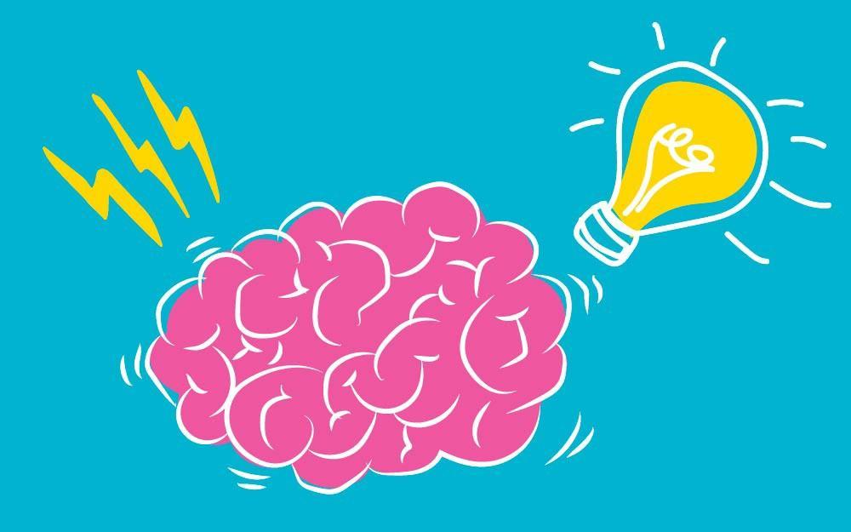

.Starting at drawing on paper and how to make ideas as a game

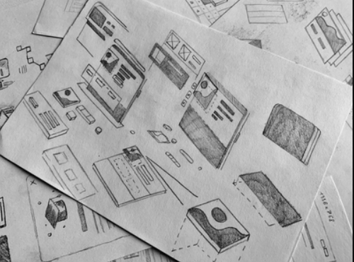

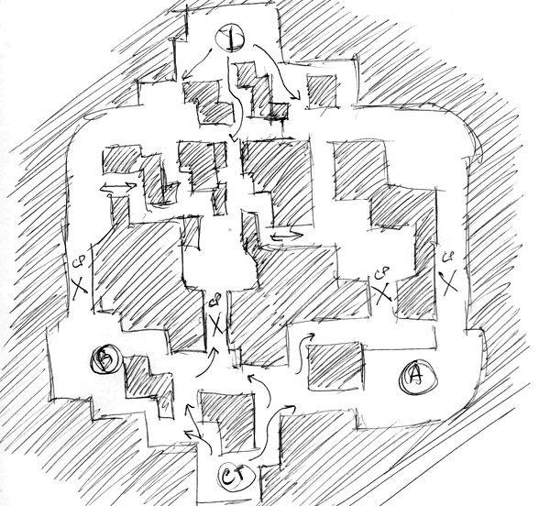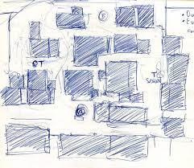

First it was that

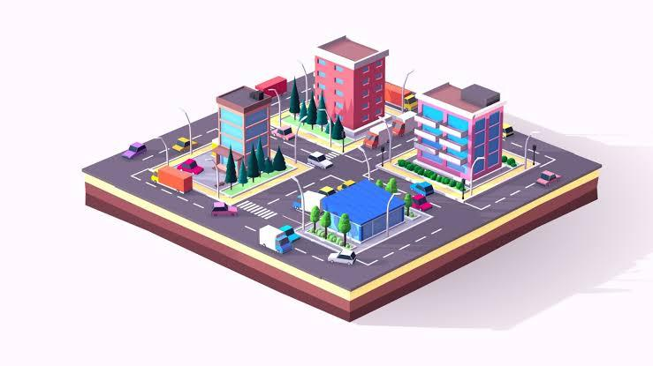

**Results of**  Game Storyboard

Before starting the game it will be a screen for education content about ADHD.

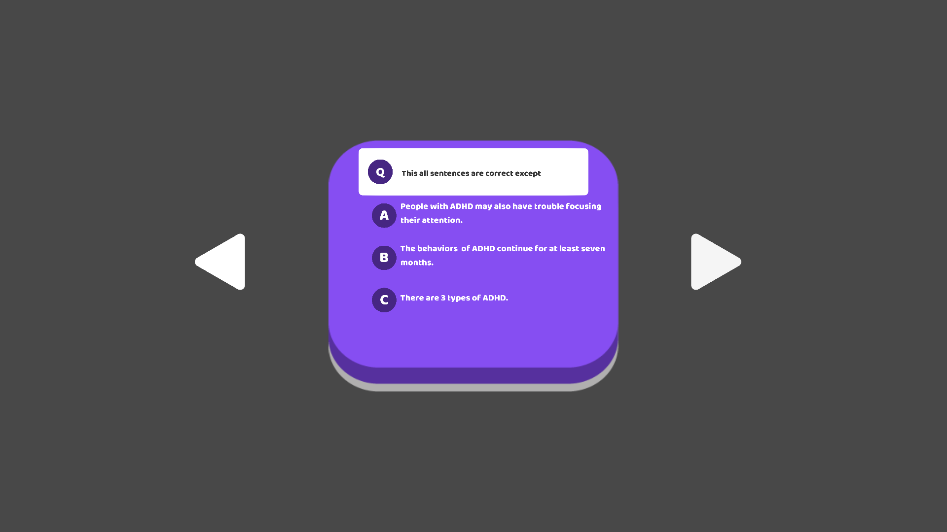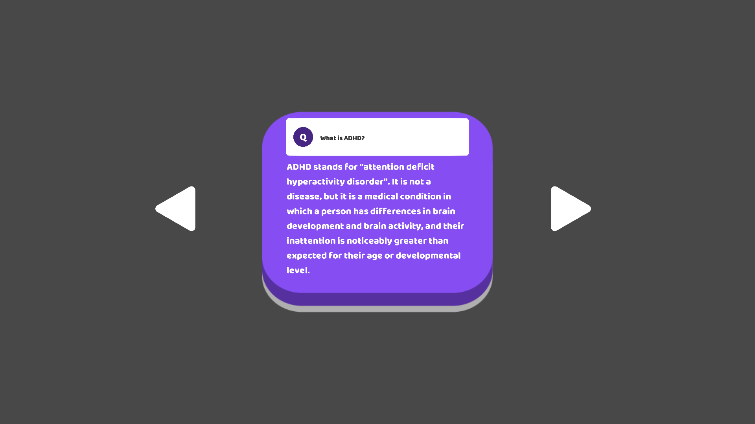

then another one to test parents about previous information.

They must get more than 80% to ensure that parents know everything about adhd, so the child can use it.

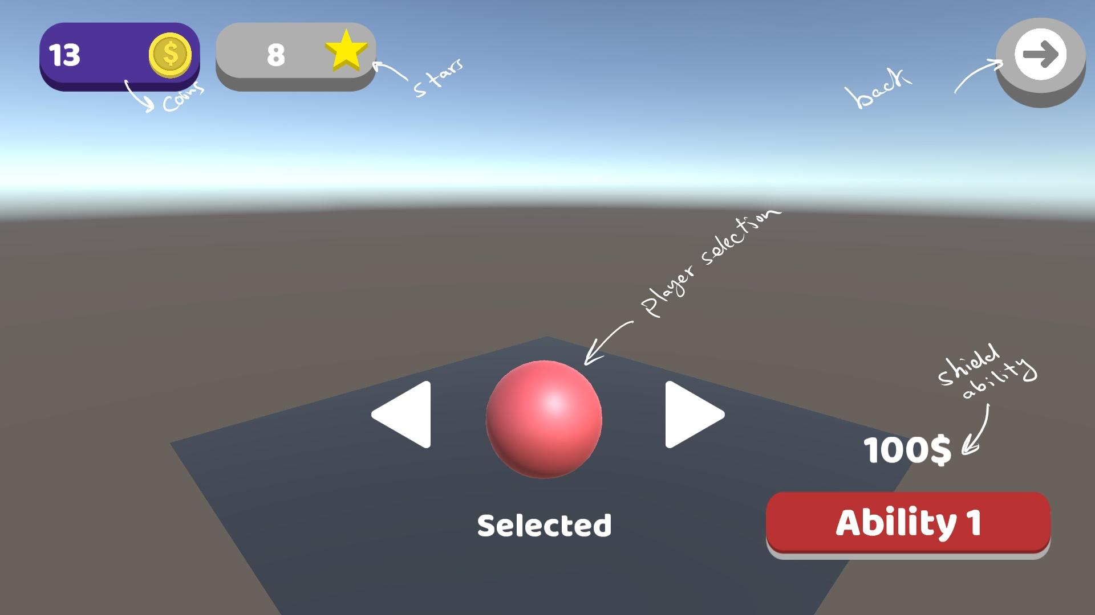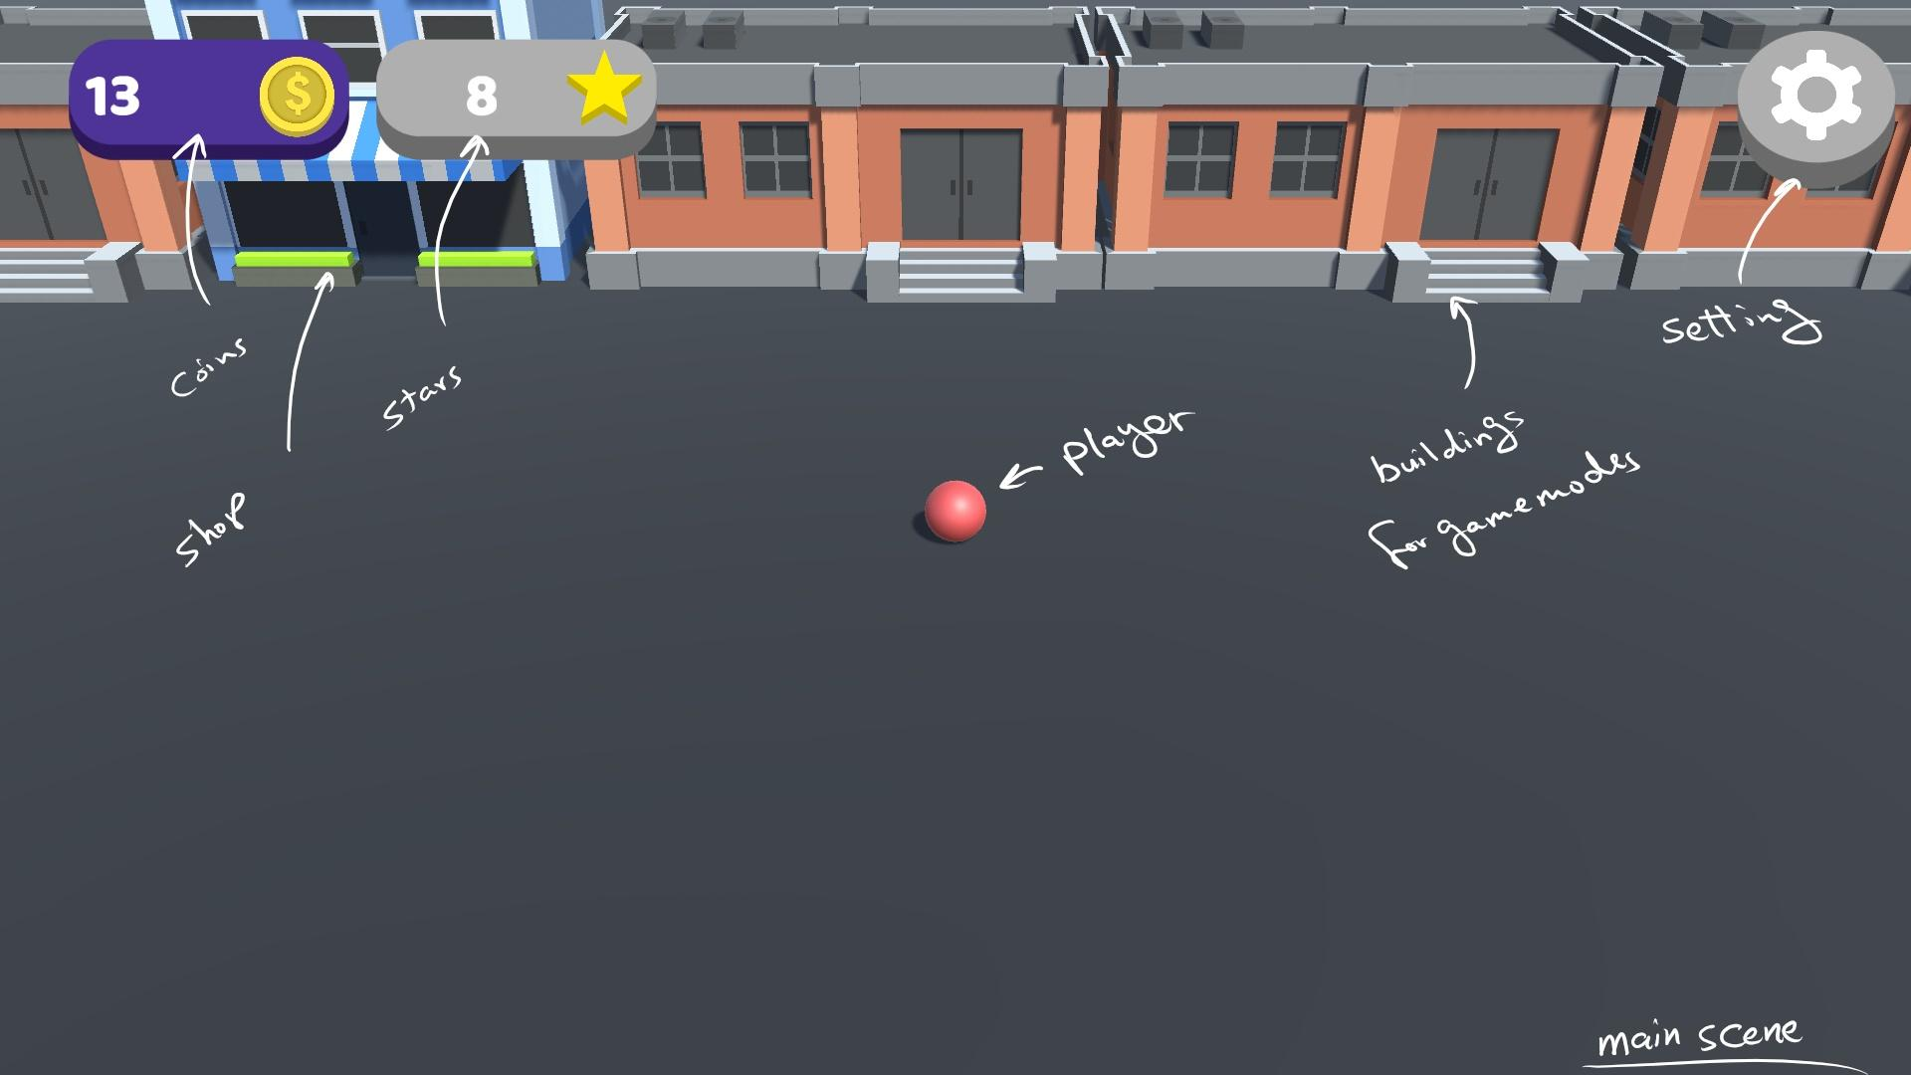

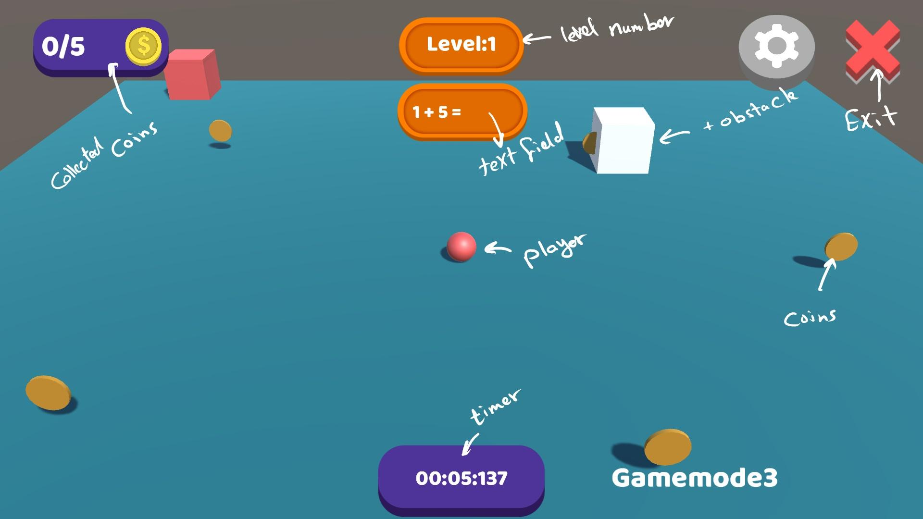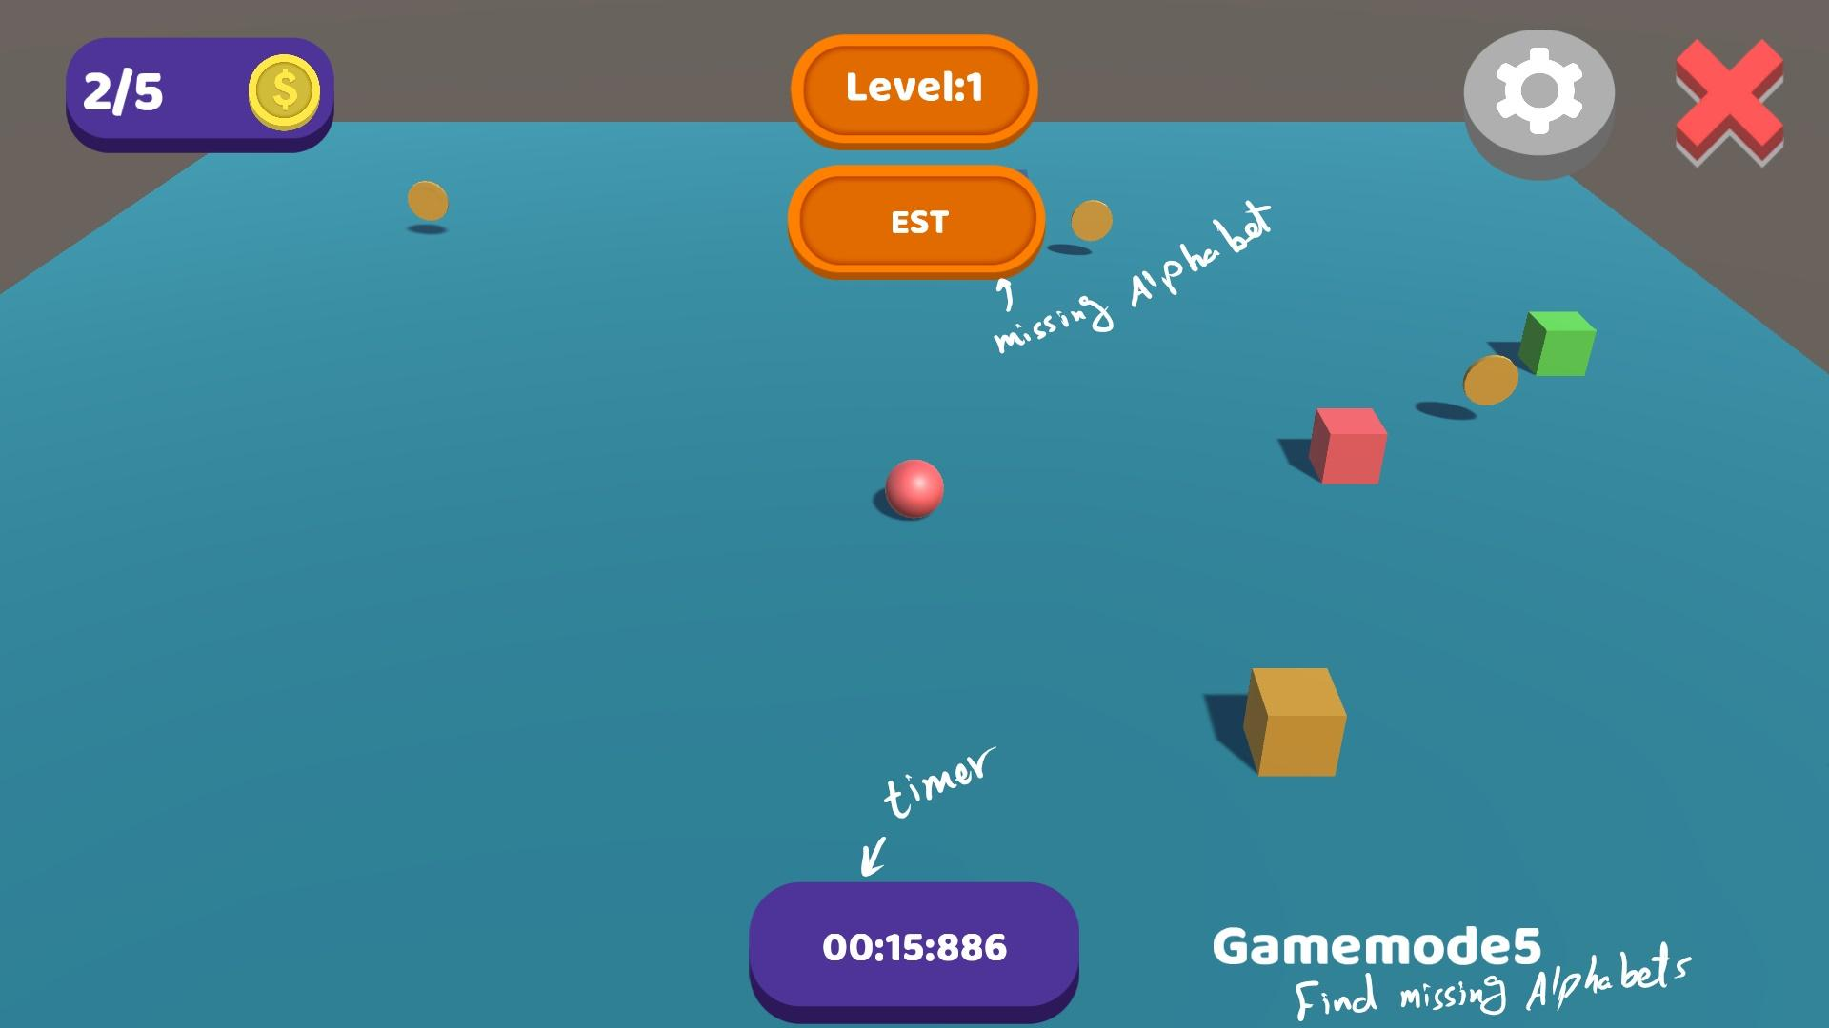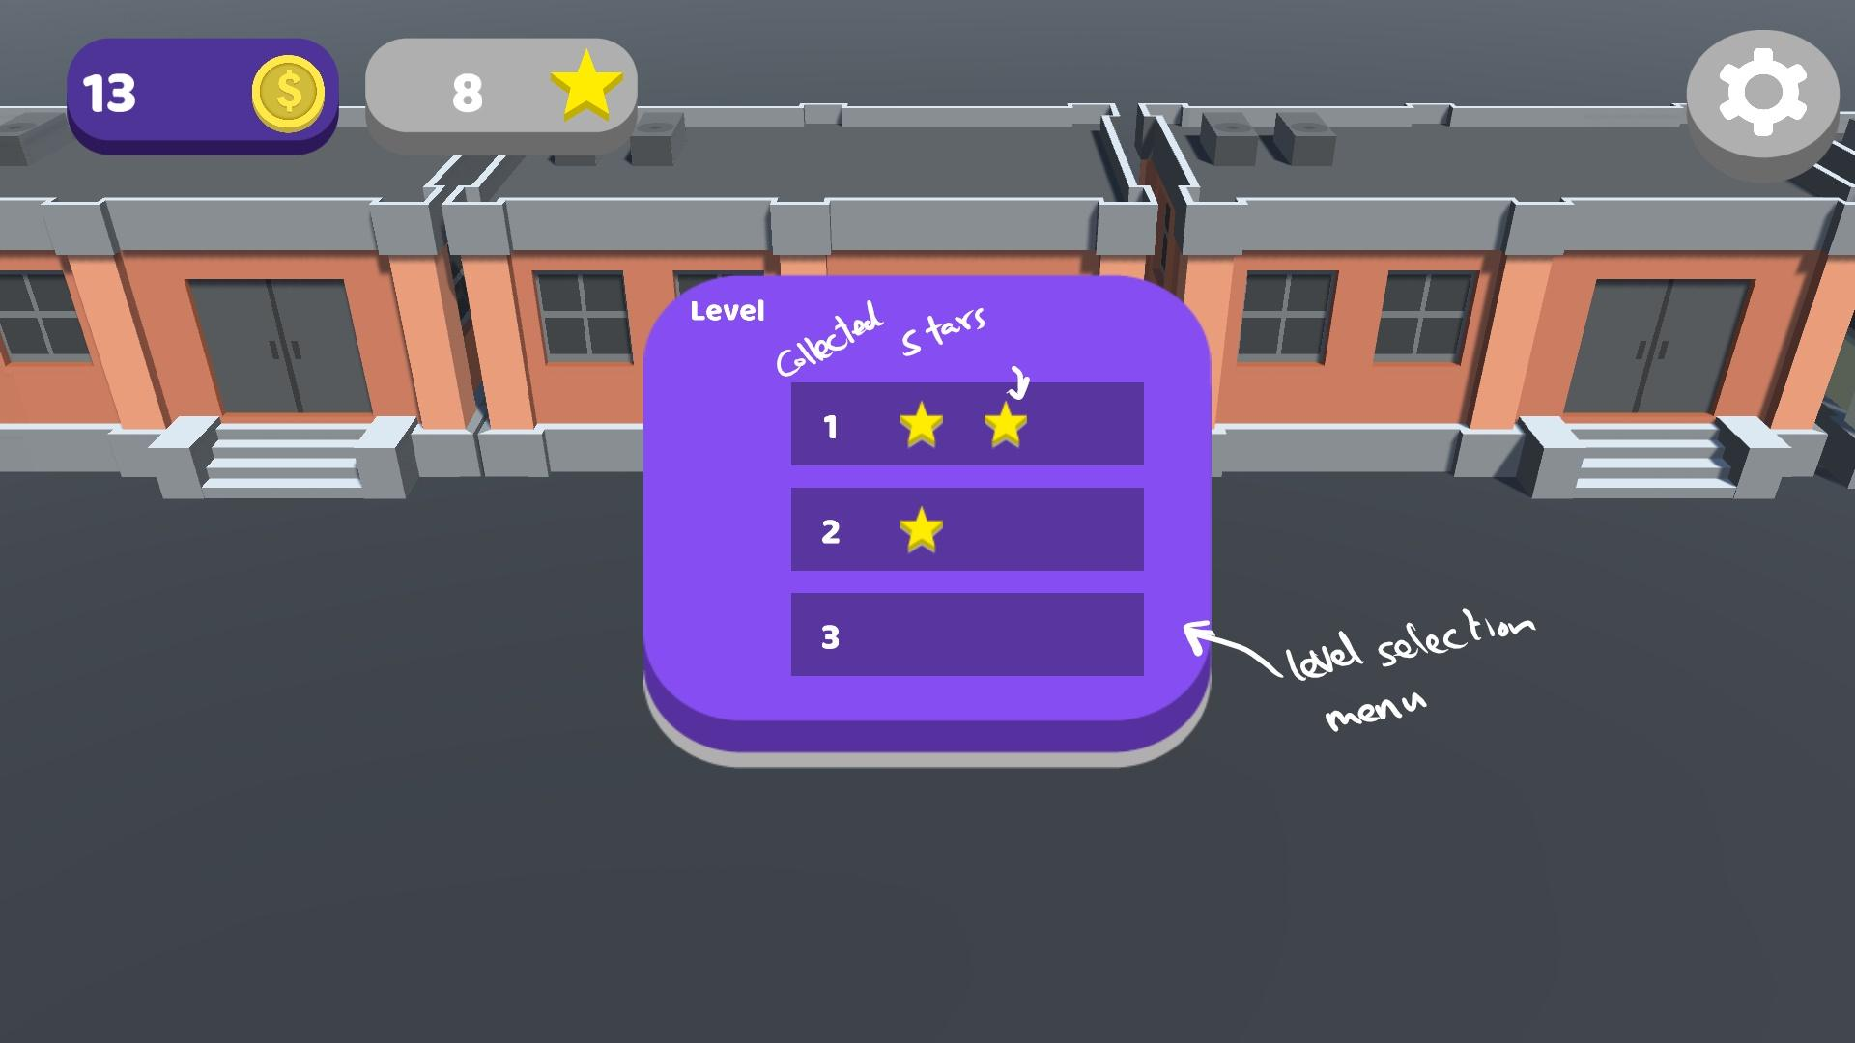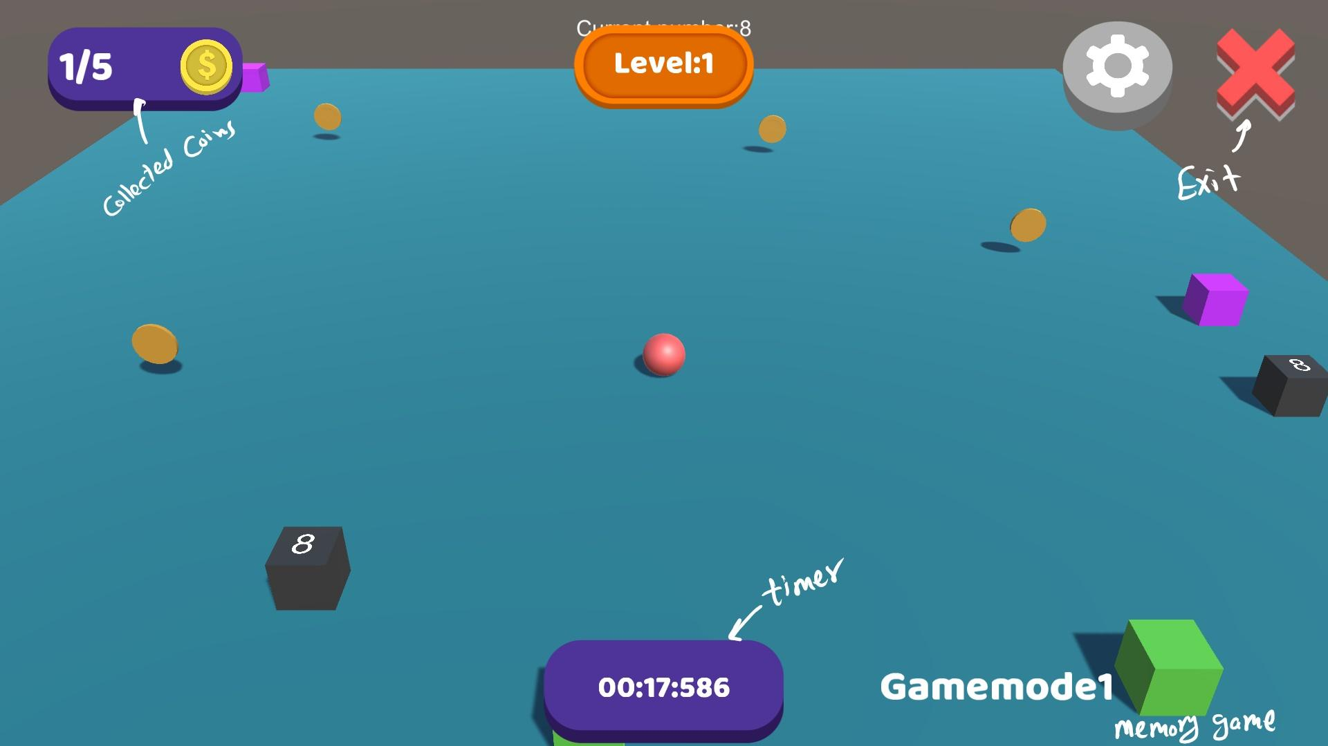

**At the end**

It will be a final report which displays what is the final total presence of all games which children play.

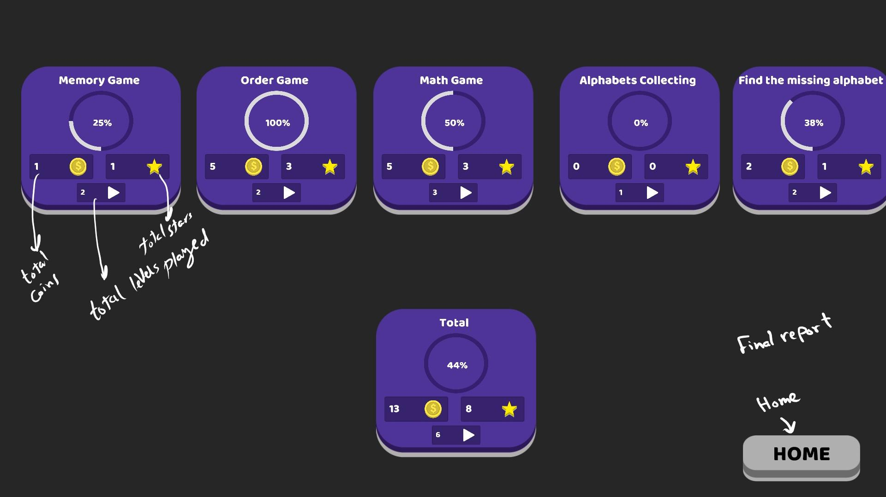

After much medical research as a guide, it will be like that.

## 4.4 Game UI

**1. Main Screen UI**

**The space is spacious and not distracting.**

**The icons are simple and expressive.**

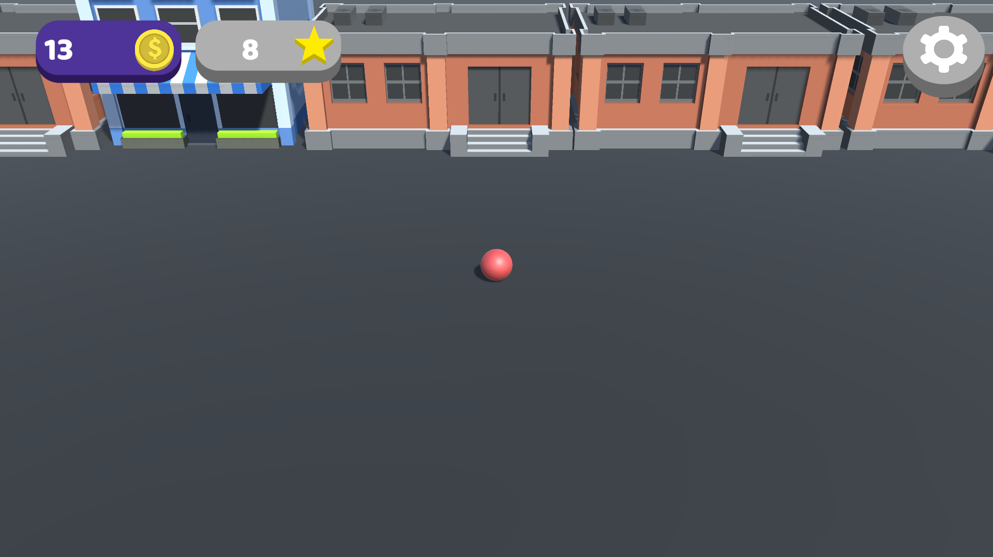

**2. Game Shop UI**

**Relying more on the middle area to focus on it to choose the tool to play with.**

**Choose the location of the button on the right for easy and quick selection.**

**Reduce the number of clicks**.

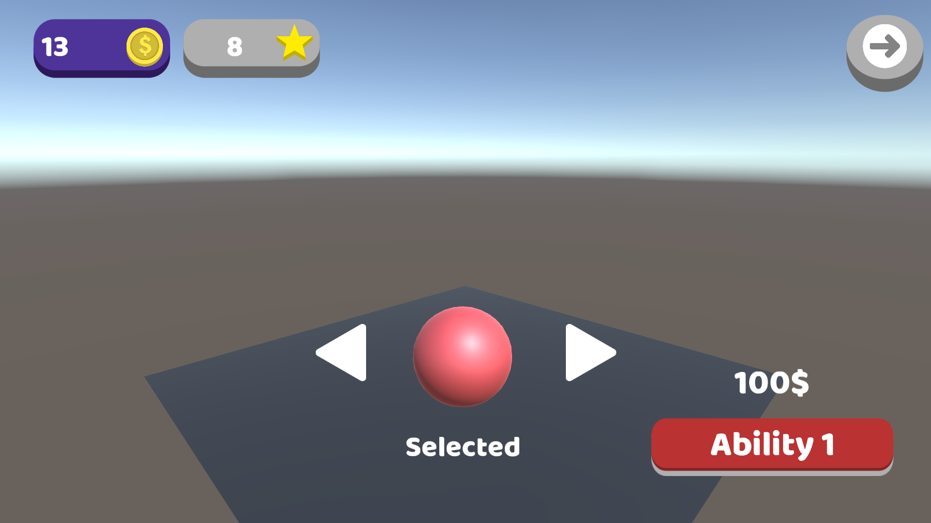

**3. Level Selection UI**

**The location of the icons is fixed and does not change in order to get used.**

**To be in simple shape and note the number of stars.**

**Community Verified icon**

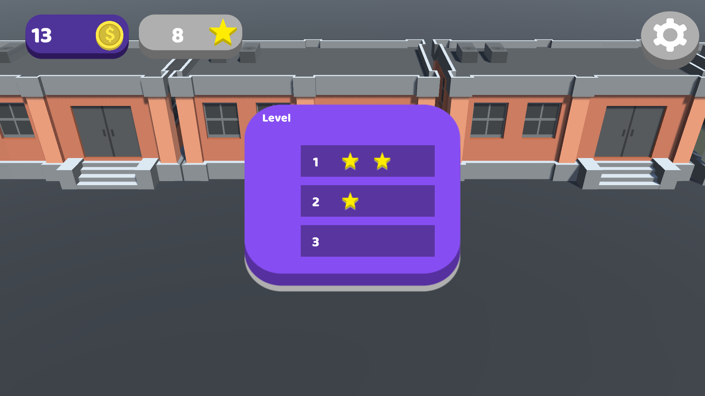

**4. Report Analysis UI (Games States)**

**A complete part in which the collection of the 5 games.**

**And the other part contains the total, the percentage, the number of stars and the coin.**

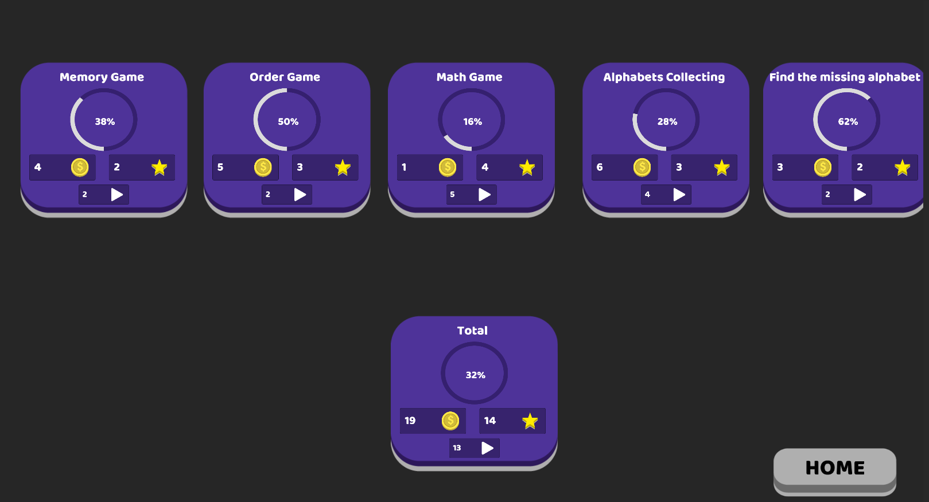

**5. Memory Game UI**

**A wide space between each box to see the number for the longest time when it gets stuck in it.**

**The presence of the coins will encourage him more to complete this main purpose so that he does not get bored.**



**6. Level Complete UI**

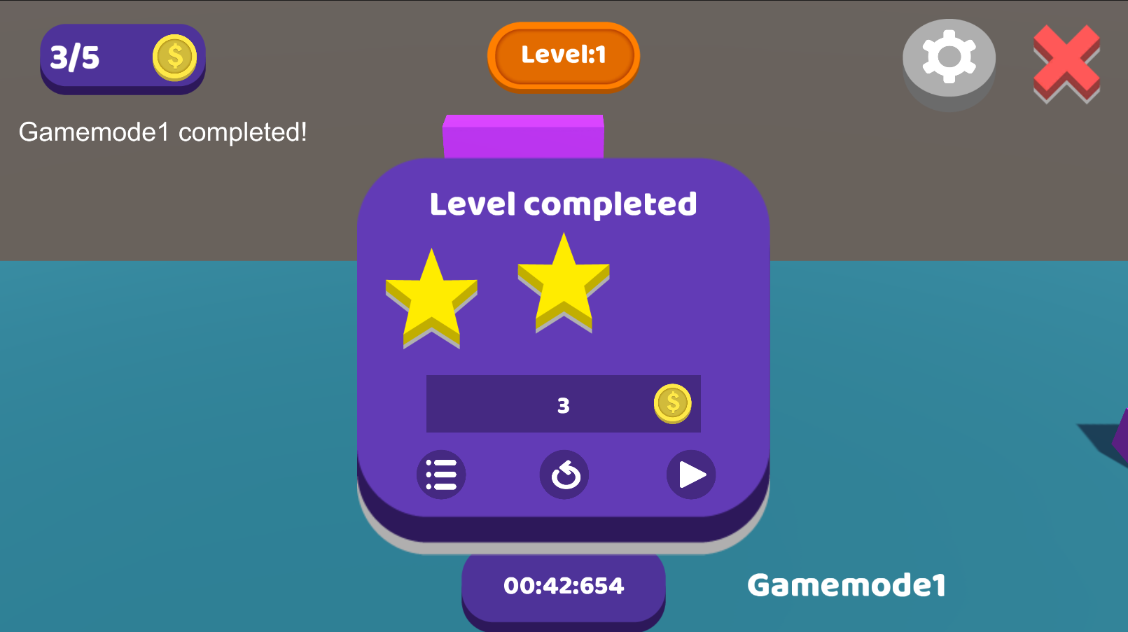

**7. Math Problems Game UI**

**If the child answered correctly, the door will open and complete.**

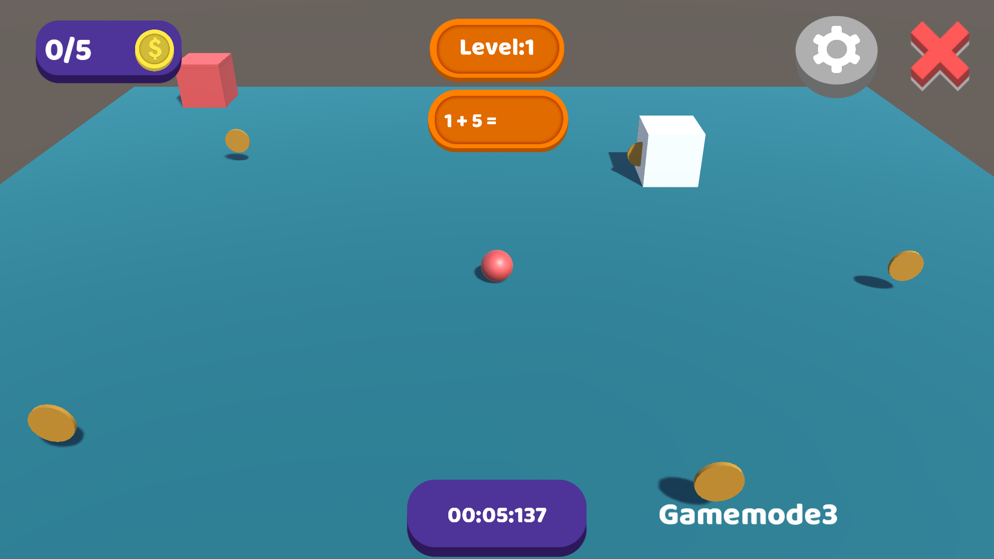

**8. Alphabet Collecting Game UI**

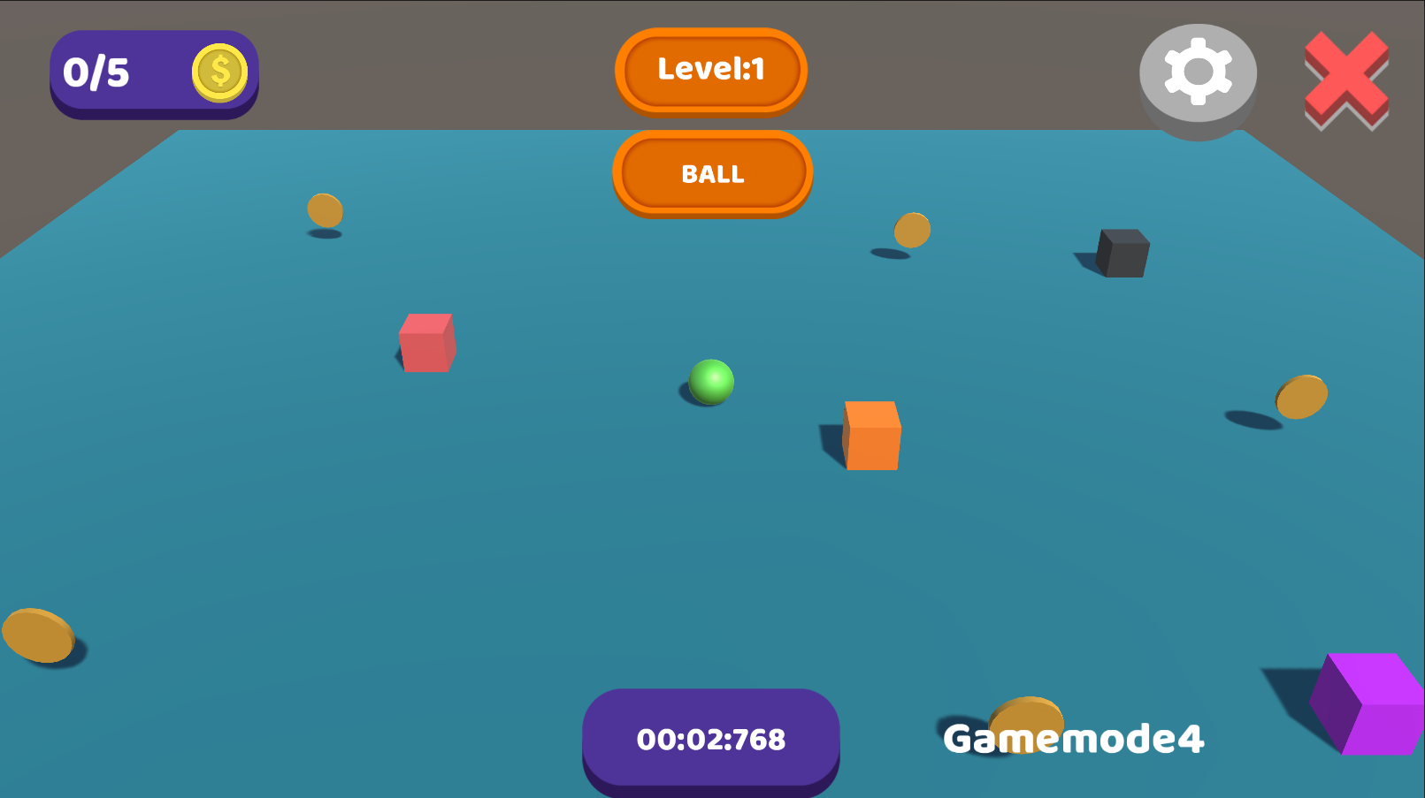

**9. Missing Alphabet Game UI**

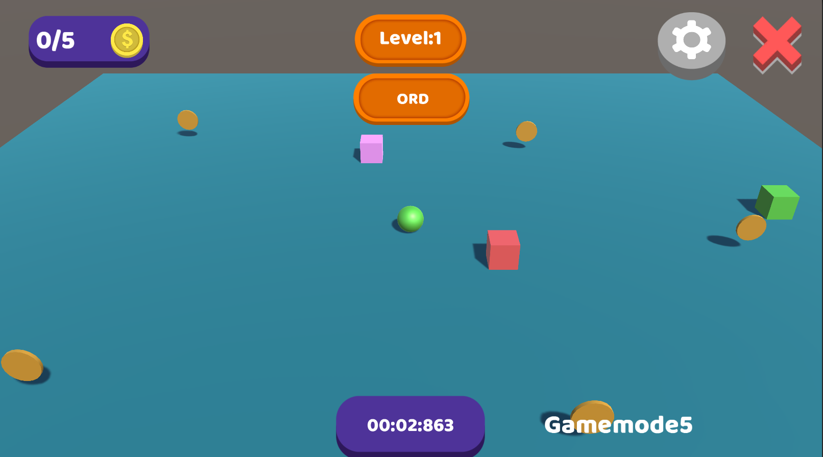

**10. Music & Sound Settings UI**

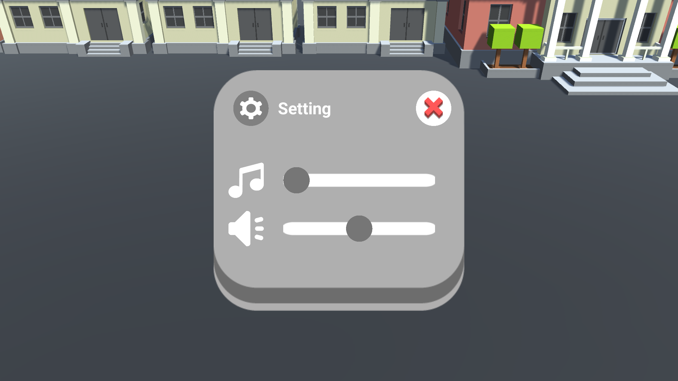

**11. Math & Alphabets UI**

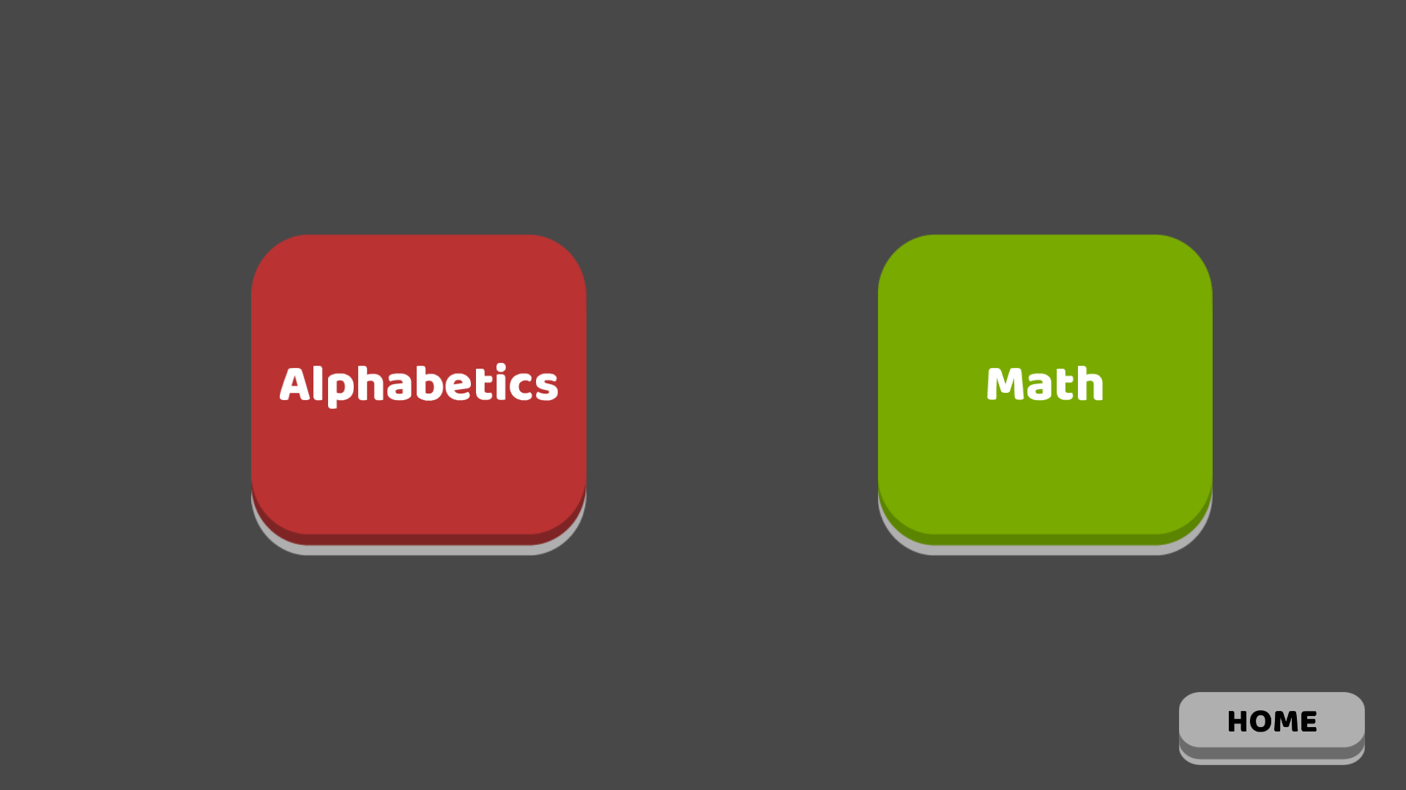

**12. Math Lessons UI**

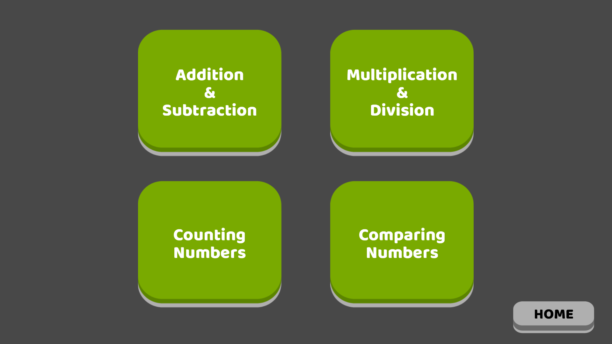

**13. Alphabets Lessons UI**

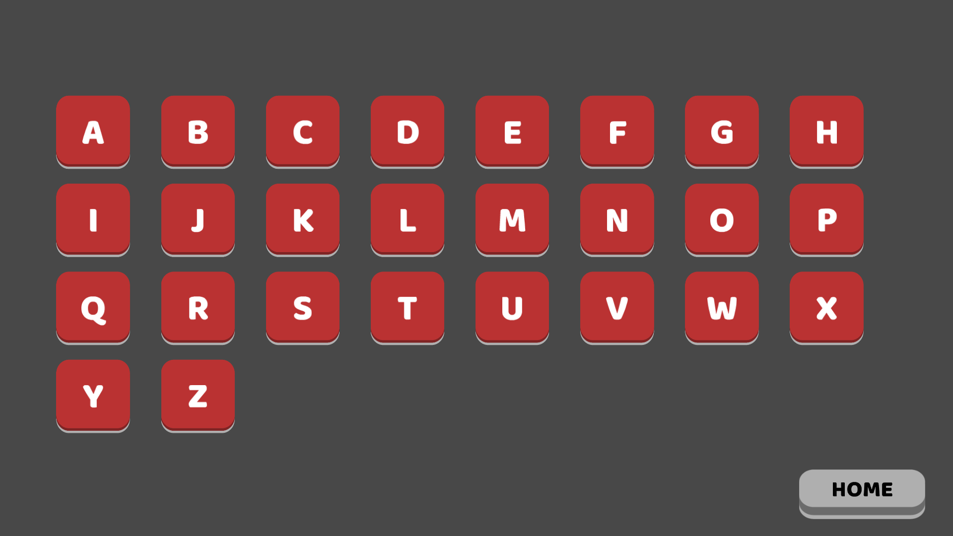

**14. ADHD Content & MCQs test UI**



## 